Embedd your pig scripts inside a java program by following the steps in the below blog.

What is Embedded Pig?

Embedded Pig lets you enable the control flow in Pig scripts. Pig can be embedded in Java, Python, and JavaScript scripting languages using a JDBC- like compile, bind run model.

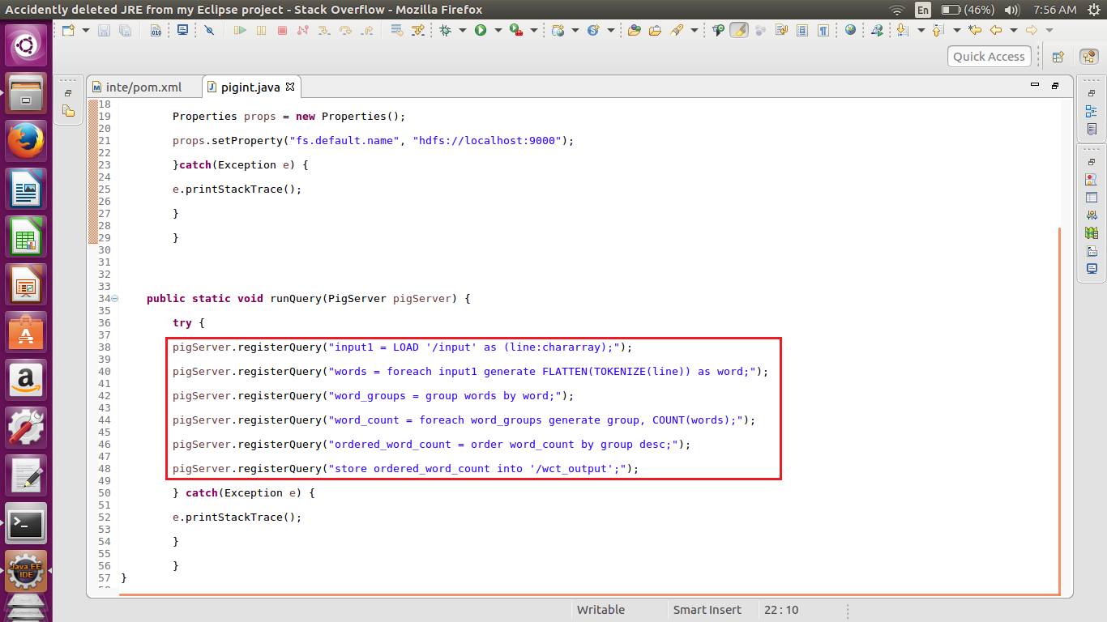

How to Run the Embedded Pig

To run an embedded Pig, you need to convert your Java project into a Maven project.

To convert into Maven Project, Right Click on the Project–>Configure–>Convert to Maven Project.

After converting, you can see a target file created and inside the target file, you can see pom.xml files. In that file, add the below dependencies:

<dependencies>

<dependency>

<groupId>org.apache.hadoop</groupId>

<artifactId>hadoop-hdfs</artifactId>

<version>2.7.1</version>

</dependency>

<dependency>

<groupId>org.apache.hadoop</groupId>

<artifactId>hadoop-client</artifactId>

<version>2.7.1</version>

</dependency>

<dependency>

<groupId>commons-io</groupId>

<artifactId>commons-io</artifactId>

<version>2.4</version>

</dependency>

<dependency>

<groupId>log4j</groupId>

<artifactId>log4j</artifactId>

<version>1.2.16</version>

</dependency>

<dependency>

<groupId>org.apache.pig</groupId>

<artifactId>pig</artifactId>

<version>0.15.0</version>

</dependency>

<dependency>

<groupId>org.antlr</groupId>

<artifactId>antlr-runtime</artifactId>

<version>3.4</version>

</dependency>

</dependencies>



